Week 2 Bioinformatics Assignment
Student name:雷嘉莉 Date: 2026-09-06
Research interest: Gut microbiome interactions with obesity and glucose metabolism.

0. Assigned papers from the Week 2 folder
- Find and read two research papers in the folder and answer following question based on these two papers.
  - Question 1: Use the PICO/PECO, what are they for these two papers?
  - Question 2: What kind of dataset or data type these two papers use?
  - Question 3: What is the hypothesis of these two research?
Field | Huang et al. 2023: infant eczema | Priya et al. 2022: host–microbiome associations
Population/problem | Full-term, vaginally delivered infants from mother–infant pairs in Guangzhou, China, followed from birth to 6 months; final analysis included 34 infants. | Participants from CRC, IBD, and IBS cohorts with paired colonic-mucosal host transcriptomic and microbiome data, together with disease-appropriate controls; 208 paired samples.
Exposure/intervention | Development of infantile eczema by 6 months of age. | Gastrointestinal disease status: CRC, IBD, or IBS.
Comparison | Infants who did not develop eczema by 6 months. | Corresponding non-disease controls for each disease cohort.
Outcome | Early-life gut microbiome diversity, community structure, microbial network complexity, and network stability during the first 3 months. | Shared and disease-specific associations between gut microbial taxa and host gene expression or biological pathways.
Dataset/data type | Longitudinal meconium and fecal samples at birth and 1, 2, and 3 months; 16S rRNA amplicon sequencing, ASV profiles, clinical metadata, and microbial network analyses. | Paired colonic-mucosal host RNA-seq and 16S rRNA microbiome data from 208 samples across CRC, IBD, and IBS cohorts.
Falsifiable hypothesis | Infants who develop eczema will show abnormal gut microbiome maturation, including differences in diversity, community structure, and interaction-network complexity or stability, compared with infants who remain eczema-free. | Host gene expression and gut microbial abundance will show both shared and disease-specific coordinated associations across CRC, IBD, and IBS; the same host pathway may be linked to different taxa in different diseases.

1. Broad topic and refined question
Question funnel worksheet | Student response
Broad domain | Human gut microbiome and metabolic disease.
Sub-field | Gut microbiome and metabolic disease.
Specific phenomenon | Obesity and type 2 diabetes are associated with changes in gut microbiota and microbial metabolites.
Testable hypothesis | Adults with obesity or type 2 diabetes have different gut microbiome composition or function and metabolite profiles compared with metabolically healthy adults.
Apply PECO | P — Population: Adults with available metabolic and gut microbiome data.  E — Exposure: Obesity, type 2 diabetes, or metabolic dysregulation.  C — Comparison: Metabolically healthy or normal-weight adults.  O — Outcome: Gut microbiome composition, microbial functions, microbial metabolites, or metabolic biomarkers.
Dataset/data type | Human stool microbiome data with clinical metadata; metabolomics or other metabolic measurements may also be included.
Minimal analysis plan | Data: Use human microbiome datasets with disease status or metabolic measurements and basic covariates.  Method: Perform sequencing quality control, microbial diversity analysis, differential abundance or functional analysis, and covariate-adjusted statistical tests.  Output: Present group comparisons, diversity plots, heatmaps, and associations between microbial features and metabolic traits.  Validation: Adjust for important confounders and, if possible, evaluate the findings in an independent cohort.

PECO worksheet
- Based on your research interest, refine the search in PUBMED, and sort, identify the latest and the most important studies in your field. Read this paper and answer three questions:
  - Question 1: Use the PICO/PECO, what are they for these two papers?
  - Question 2: What kind of dataset or data type these two papers use?
  - Question 3: What is the hypothesis of these two research?

PICO/PECO field | Paper 1: Tian et al. 2026 | Paper 2: Zeevi et al. 2015
Population | Unrelated US men aged 20–50 years with paired stool and fasting-blood samples, BMI, and relevant covariates; selected microbial associations were evaluated in an independent Chinese female cohort. | Adults in the main 800-person cohort and an independent 100-person validation cohort; the paper also included 26 participants in a blinded dietary-intervention phase.
exposure | Higher adiposity measured by BMI; obesity was defined as BMI ≥30 kg/m², while BMI was also analyzed continuously. | Individual-level dietary, clinical, anthropometric, lifestyle, physical-activity, and gut-microbiome features associated with postprandial glycemic responses. In the intervention phase, the exposure was a personalized diet predicted to produce lower PPGRs.
Comparison | Healthy-weight participants with BMI 18.5–24.9 kg/m² from the same discovery cohort, plus lower-versus-higher BMI comparisons as specified by the study. | Individuals or meals with different feature combinations; prediction was also compared with conventional carbohydrate-based prediction. In the intervention, the personalized “good” diet was compared with a personalized “bad” diet.
Outcome | BMI-associated gut microbial diversity and species abundance, serum metabolites and lipid profiles, SCFAs, and integrated microbiome–metabolome associations. | Postprandial glycemic response (PPGR), quantified from CGM as the 2-hour incremental area under the glucose curve; intervention outcomes also included glucose-control measures and gut-microbiota changes.
Key covariates | Age, sex, diet, physical activity, smoking, medication/supplement use, sequencing batch/depth, and other available cohort covariates. | Age, sex, baseline glucose measures, meal composition, dietary habits, physical activity, sleep, anthropometrics, blood parameters, and gut-microbiome features.
Data type | Fecal shotgun metagenomic sequencing; fasting-serum untargeted metabolomics, lipidomics, and targeted SCFA measurements; BMI and clinical metadata. | Continuous glucose monitoring; detailed meal and activity records; anthropometrics; blood tests; lifestyle/medical questionnaires; physical-activity and sleep records; gut microbiome profiles from 16S rRNA and metagenomic sequencing.
Analysis method | Multi-omics QC and normalization; differential abundance and metabolite analysis; covariate-adjusted regression; bacteria–metabolite association analysis; FDR correction; independent-cohort validation. | Machine-learning prediction of PPGR using host, meal, lifestyle, and microbiome features; independent-cohort validation; blinded randomized dietary intervention.
Falsifiable hypothesis | Obesity and higher BMI are associated with distinct gut microbial and serum metabolic profiles, and that some BMI-associated gut microbes are linked to obesity-related circulating metabolites, forming identifiable microbiome–metabolome signatures. Some of these microbial associations are expected to be reproducible in an independent population. | Postprandial glycemic responses are highly individualized and cannot be adequately predicted from food composition alone. Instead, integrating person-specific clinical, lifestyle, dietary and gut microbiome features should enable accurate prediction of individual glycemic responses, and dietary recommendations based on these predictions should reduce postprandial glucose responses.

3. PubMed search strategy
Database: PubMed. Date searched: 2026-09-06
Search log field | Student entry
Original query | ("gut microbiome"[Title/Abstract] OR "gut microbiota"[Title/Abstract]) AND (obesity[Title/Abstract] OR "glucose metabolism"[Title/Abstract] OR "glycemic response"[Title/Abstract] OR "type 2 diabetes"[Title/Abstract]) AND Humans[MeSH Terms]
AI-expanded/refined query | ("gut microbiome"[Title/Abstract]  OR "gut microbiota"[Title/Abstract]  OR "Gastrointestinal Microbiome"[MeSH Terms])  AND  (obesity[Title/Abstract]  OR "type 2 diabetes"[Title/Abstract]  OR "glycemic response"[Title/Abstract])  AND  (metagenom*[Title/Abstract]  OR multi-omic*[Title/Abstract]  OR metabolom*[Title/Abstract])  AND Humans[MeSH Terms]  AND English[Language]
Latest-study filter | AND ("2023/01/01"[Date - Publication] : "3000"[Date - Publication])
Filters used | Humans and English were applied to the overall search.  The publication-date filter from 2023 to the present was used only to identify the latest study.  No publication-date restriction was used when selecting historically important or representative studies.  Reviews, editorials, protocols, animal studies, and in vitro studies were excluded during manual screening.
Number of results | Original query: 6,394 results.  Refined query without date restriction: 1,018 results.  Latest-study query with the 2023–present filter: 533 results.
Reason for refining | The original query was broad and retrieved a mixture of observational studies, intervention studies, reviews, and papers without multi-omics data. The refined query added microbiome-related MeSH terms and omics-related terms to prioritize original human studies involving metagenomics, metabolomics, or multi-omics. A publication-date filter was then added only for identifying the latest study.
Final query selected | Two-stage search strategy:  1. Latest study query:  ("gut microbiome"[Title/Abstract]  OR "gut microbiota"[Title/Abstract]  OR "Gastrointestinal Microbiome"[MeSH Terms])  AND  (obesity[Title/Abstract]  OR "type 2 diabetes"[Title/Abstract]  OR "glycemic response"[Title/Abstract])  AND  (metagenom*[Title/Abstract]  OR multi-omic*[Title/Abstract]  OR metabolom*[Title/Abstract])  AND Humans[MeSH Terms]  AND English[Language]  AND ("2023/01/01"[Date - Publication] : "3000"[Date - Publication])  Used to identify Tian et al. 2026 as the latest study.  2. Important/representative study query:  ("gut microbiome"[Title/Abstract]  OR "gut microbiota"[Title/Abstract]  OR "Gastrointestinal Microbiome"[MeSH Terms])  AND  (obesity[Title/Abstract]  OR "type 2 diabetes"[Title/Abstract]  OR "glycemic response"[Title/Abstract])  AND  (metagenom*[Title/Abstract]  OR multi-omic*[Title/Abstract]  OR metabolom*[Title/Abstract])  AND Humans[MeSH Terms]  AND English[Language]  Used to identify Zeevi et al. 2015 and Qin et al. 2012 as important or representative studies.

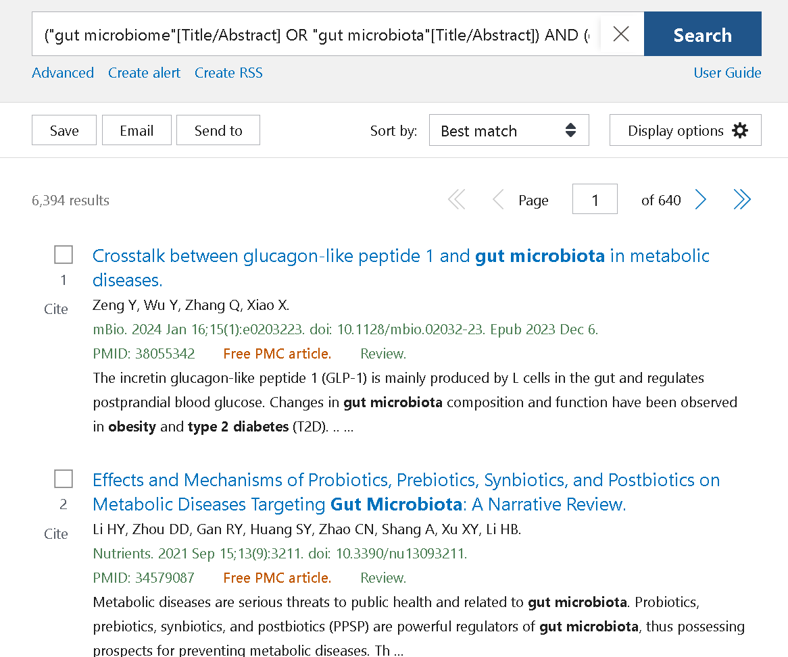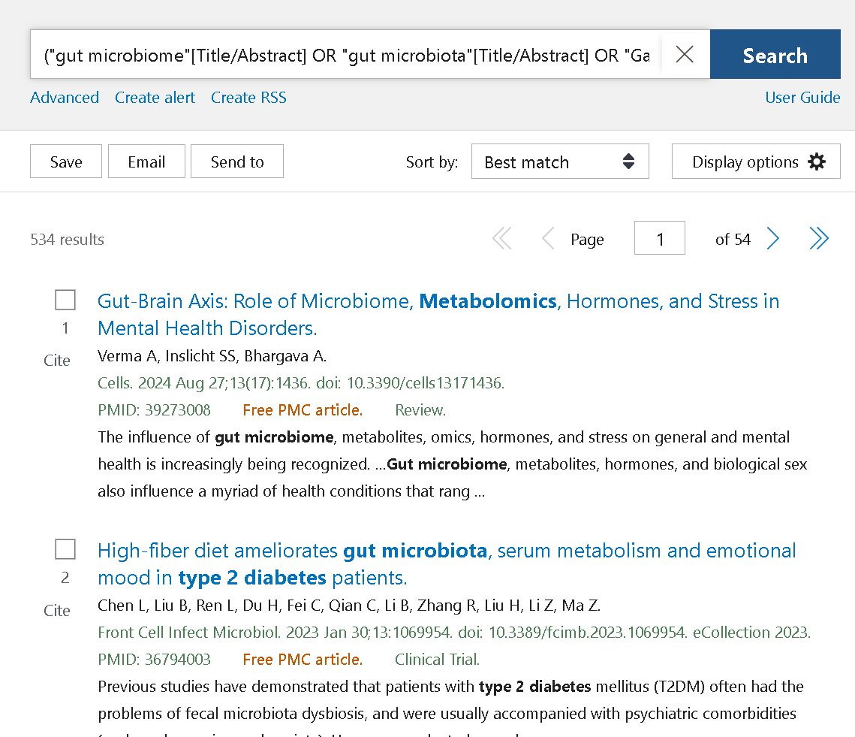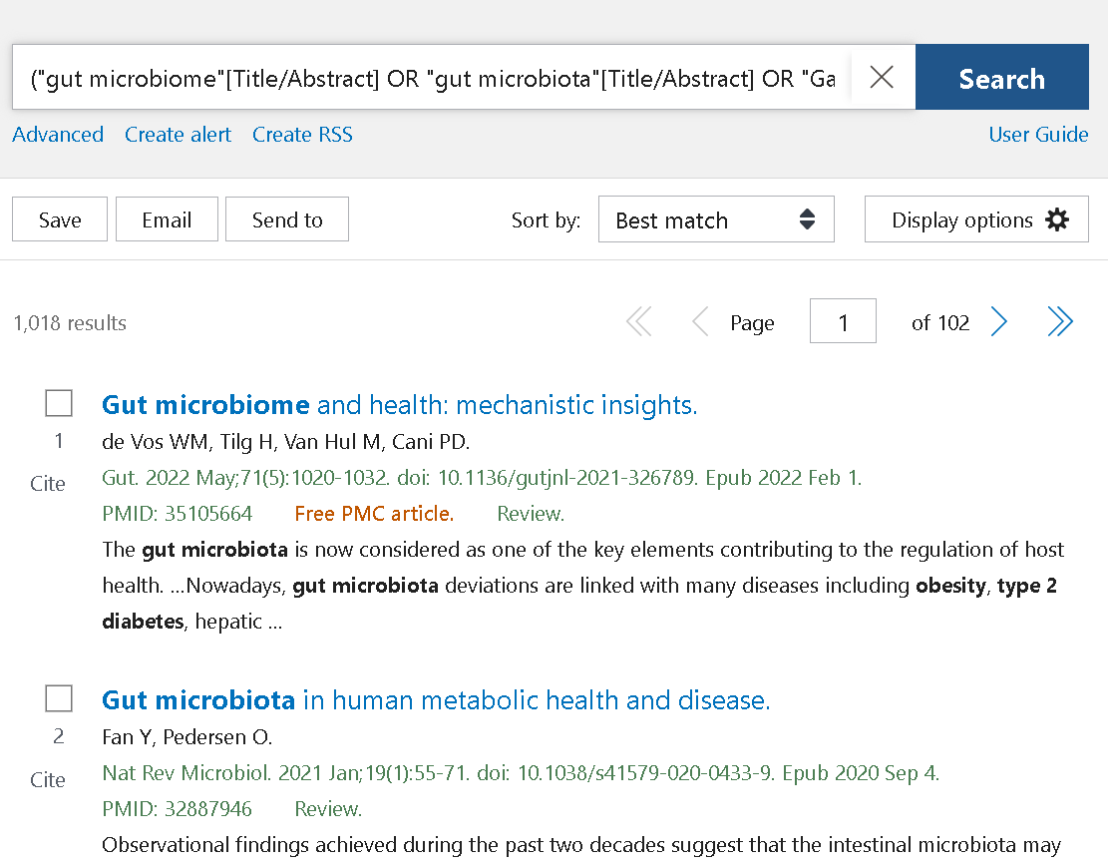

4. Selected papers and source extraction
Paper extraction field | Paper 1：Tian 2026 | Paper 2：Zeevi 2015 | Paper 3：Qin 2012
Citation verified? | Yes; PMID 42429485 and DOI 10.1093/jambio/lxag172. | Yes; PMID 26590418 and DOI 10.1016/j.cell.2015.11.001. | Yes; PMID 23023125 and DOI 10.1038/nature11450.
Study question | Which gut bacteria, serum metabolites, and bacteria–metabolite links are associated with obesity/BMI? | Can host, diet, lifestyle, and gut microbiome features predict individual postprandial glycemic responses? | Which gut microbial markers and functions distinguish people with type 2 diabetes from controls?
Data type and sample size | Paired stool metagenomics and serum metabolomics/lipidomics/SCFAs with BMI in 495 US men; independent Chinese cohort for validation. | Week-long CGM and meal records in an 800-person cohort; independent 100-person validation; blinded dietary intervention. | Two-stage deep shotgun metagenomic study of 345 Chinese individuals, plus an additional 23-person classification assessment.
Key method | Multi-omics association testing, covariate-adjusted analysis, bacteria–metabolite associations, and independent validation. | Machine-learning model integrating clinical, dietary, anthropometric, activity, and gut-microbiome features; blinded intervention. | Metagenome-wide association study with species-level markers and metagenomic linkage groups.
Main finding | Identified 52 bacteria and 31 metabolites associated with BMI; selected associations were validated in an independent cohort. | Individual glycemic responses varied widely; the model predicted responses in an independent cohort and personalized diets lowered responses in the intervention. | Reported approximately 60,000 T2D-associated markers, reduced universal butyrate producers, increased opportunistic pathogens, and functions related to sulfate reduction and oxidative-stress resistance.
Limitation | Observational and cross-sectional; residual confounding and population/sex differences may affect generalizability. | Short-term intervention and cohort-specific model; prediction does not by itself prove microbiome causality. | Cross-sectional case–control design; treatment, diet, and geography may confound associations; full text may be subscription-restricted.
Relevance to my question | Directly supplies the latest obesity-focused multi-omics example. | Landmark example of integrating gut microbiome data with host and lifestyle features for glucose-metabolism prediction. | Foundational T2D metagenomic evidence motivating the butyrate-pathway hypothesis.
Quality concern | The abstract does not establish causality; read the full paper for exact validation cohort definitions. | Later studies debate reproducibility and within-person response variability; discuss this limitation. | Interpret associations as disease markers, not demonstrated causes; verify full-text methods if using details beyond the abstract.

5. Evidence synthesis
Consensus: human gut microbiome composition and microbial functions are associated with obesity, type 2 diabetes, and postprandial glucose responses. Multi-omics and machine-learning approaches can identify candidate microbial and metabolite signatures, and several studies include an independent validation cohort.
Controversy: most associations are observational, and cohort differences, medication use, diet, sequencing platform, and within-person variability can change the apparent signal. A predictive model can be useful without identifying a causal mechanism; therefore, predictive accuracy and causal interpretation must be reported separately.
Gap: reproducible bacteria–metabolite links across populations and sexes remain incomplete. A useful next study should combine paired stool metagenomics and serum metabolomics with careful covariate control, external validation, and, where possible, longitudinal or intervention data.

6. Proposed analysis plan
Analysis-plan field | Proposed plan
Dataset | Discovery cohort with paired stool shotgun metagenomics, fasting-serum metabolomics/lipidomics/SCFAs, BMI, and covariates; independent cohort for validation.
Comparison | Continuous BMI model plus prespecified healthy-weight versus obesity comparison; do not switch thresholds after seeing the results.
Method | Read and metabolite QC; remove contaminants and low-prevalence features; normalize compositional and metabolite data; fit covariate-adjusted regression models; calculate bacteria–metabolite associations; control FDR; repeat selected tests in the validation cohort.
Output figure | Volcano or forest plot of adjusted BMI associations; heatmap/network of significant bacteria–metabolite links; discovery-versus-validation effect-size plot.
Validation | Independent-cohort replication, sensitivity analyses excluding recent antibiotics or relevant medications, and stratified analyses by sex where sample size allows.
Limitation | Cross-sectional data cannot establish temporal order or causality; residual confounding, compositionality, missing metadata, and population differences may limit interpretation.

7. AI disclosure and verification log
AI verification log | Student entry
Prompt used | “Using the supplied assignment requirements and verified PubMed/DOI records, help organize a concise Week 2 question funnel, separate PECO answers for the two selected papers, PubMed search log, two-paper extraction table, evidence synthesis, and analysis plan. Do not invent result counts, methods, sample sizes, or findings.”
AI output accepted | Query-term expansion, table organization, wording improvement, and a draft synthesis after checking the cited records.
AI output rejected | Any citation, sample size, result count, or method not supported by the original paper or PubMed/DOI record; any causal wording for an observational association.
Citation checked in PubMed/DOI? | Yes for Tian (PMID 42429485)，Zeevi (PMID 26590418) and Qin（PMID 23023125）
Claim that required verification | Tian cohort sizes and validation details; Zeevi cohort/intervention numbers; actual PubMed result counts.
How the claim was verified | The claims were verified by checking the PubMed records, DOI pages, and article abstracts. Citation details, cohort sizes, data types, and main findings were compared with the information reported in these records.
Remaining uncertainty | PubMed result counts may change over time. Some full texts may require institutional access. The observational associations reported in these studies do not establish causality, and differences between cohorts may limit generalizability.

AI tools were used for query expansion, abstract screening support, and language polishing. All citations were verified in PubMed, DOI lookup, or journal pages, and all final interpretations were checked against the original sources.

References
- Tian B, Liu Y, Su K-J, et al. Multi-omics analysis identify novel microbiome-metabolome signatures associated with obesity. Journal of Applied Microbiology. 2026;137(7):lxag172. https://doi.org/10.1093/jambio/lxag172. PMID: 42429485.
- Zeevi D, Korem T, Zmora N, et al. Personalized Nutrition by Prediction of Glycemic Responses. Cell. 2015;163(5):1079–1094. https://doi.org/10.1016/j.cell.2015.11.001. PMID: 26590418.
- Huang et al. Microbial network signatures of early colonizers in infants with eczema. Assigned-paper PDF supplied in the Week 2 folder.
- Priya S, et al. Identification of shared and disease-specific host gene–microbiome associations across human diseases using multi-omic integration. Nature Microbiology. 2022.
- Qin J, Li Y, Cai Z, et al. A metagenome-wide association study of gut microbiota in type 2 diabetes. Nature. 2012;490(7418):55–60. https://doi.org/10.1038/nature11450. PMID: 23023125.

